# Classification vs Clustering

|  |  |
| --- | --- |
| Classification | Clustering |
| Data have labels | Data don’t have label |
| Find a model to label data | Find an optimal cluster |

## Clustering

* Hierarchical clustering: bottom-up and top-down
* Distance between cluster (min,max,avg,centroid)

# K-means (Clustering)

## Algorithm

* Given: $x_{1},x_{2},…x_{n}∈R^{d} and k$
* Initial: defined initial clusters $C_{1}^{0},C_{2}^{0},…C_{k}^{0}$
* Loop:
  + Compute mean $u_{j}^{t}$ of cluster $C_{j}^{t}$: $u_{j}^{t}=\frac{1}{\left|C_{j}^{t}\right|}\sum_{x∈C_{j}^{t}}{x_{i}}$
  + For each $x_{i} find closest mean: m\left(i\right)= {argmin}_{j} d(x_{i},u_{j}^{t})$ (1)
  + Move $x_{i}$ to cluster m(i): $x∈C_{m(i)}^{t+1}$ (2)
  + Iterate until stopping criterion

## Proof of convergence:

* $D_{t}$: sum of distances of all nodes to their belonged cluster.
$D_{t}$ $= \sum_{j=1}^{k}{\sum_{x∈C_{j}^{t}}{d\left(x_{i},μ_{j}^{t}\right)}}$

* $D_{t}$ $≥ \sum_{j=1}^{k}{\sum_{x∈C_{j}^{t}}{d\left(x_{i},μ_{m\left(i\right)}^{t}\right)}}= \sum_{j=1}^{k}{\sum_{x∈C_{j}^{t+1}}{d\left(x_{i},μ_{m\left(i\right)}^{t}\right)}} because d\left(x_{i},μ_{m\left(i\right)}^{t}\right)≤d\left(x_{i},μ_{j}^{t}\right)$ (1)
* $≥ \sum_{j=1}^{k}{\sum_{x∈C_{j}^{t+1}}{d\left(x_{i},μ_{j}^{t+1}\right)}}$ because $\sum_{x∈C_{j}^{t+1}}{d\left(x_{i},μ_{j}^{t+1}\right)}≤ \sum_{x∈C_{j}^{t+1}}{d\left(x_{i},μ_{j}^{t}\right)}$ (2)
$= D_{t+1}$

* $D_{t}$ is decreasing during the iterations => reach **local minimum** after finite number of step
* $S$ toping criteria: no element move, after number of iterations or value $D_{t}-D_{t+1}<θ$

## Comment:

* Strength: fast
* Limits: require computation of mean (non-scalar data), specific k and sensitive with outliner

## K-medoids

* Use the most central object of cluster, robust to outliner

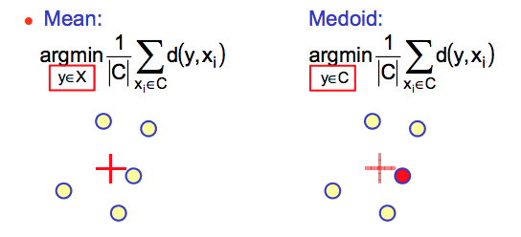

## Minimum Description Length

* Increase k, then $D_{k}= \sum_{j=1}^{k}{\sum_{x∈C_{j}^{t}}{d\left(x_{i},C_{j}\right)}}$ decrease => not mean it will be better
* Minimum Description Length principle: penalty based on transmitting centroid information (regularization)
* MDK for k-means: $min⁡(D_{k}+kC_{0})$

# K-Nearest Neighbors

* NN rule: assign x to class $C\left(x_{i*}\right) where i^{*}=argmin d(x,x_{i})$
* K-NN: assign x to most frequent class among k-NN

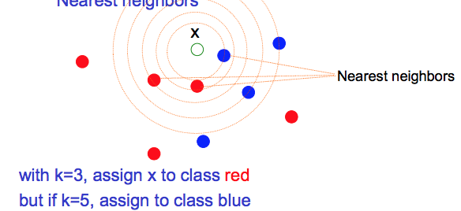

* Pros and Cons
  + Pros: flexible, simple, Good performance (large data), regression ( average instead of vote)
  + Cons: Needs lot of data, Intensive Computation, Hard to speed up (high dimension), difficult to choose weight/distance

# Bayesian Classification

* + P(C|x): posterior probability of class C given X
  + P(C): prior probability of class C
$p\left(x,C\right)= p\left(x | C\right).p\left(C\right), p\left(x\right)=\sum_{C}{p(x,C)}$

* Modeling
  + $p\left(x,C\right)$ is generative model and $p\left(C|x\right)$ is discrimative model
* Generative model
  + Can model classes independently
  + Easy to add one class

|  |
| --- |
| Bayesian |
| Input $\left(x_{i},y_{i}\right) for i=1…n. x_{i}∈R^{d} and y= \{-1,1\}$ |
| Output $f\left(x,θ\right)= y.$ Map point x to class y |
|  |
| Training Maximum likelihood => find general distribution of dimension ( p(x_i),p(y_i)) |

<http://www.cs.columbia.edu/~mcollins/courses/6998-2012/lectures/lec6.1.pdf>

|  |
| --- |
| Gaussian |
| Input continuous valued attribute |

4